

**Inventory Management Application Manual**

**Contents:**

**Main Inventory View**- - - - - - - - - - - - - - - - - - - - - - - - - - - - - - - - - - - - - - - - - - - - - - **1ー3**

Viewing Inventory - - - - - - - - - - - - - - - - - - - - - - - - - - - - - - - - - - - - - - - - - - - - - - - - - 1

Inventory Options - - - - - - - - - - - - - - - - - - - - - - - - - - - - - - - - - - - - - - - - - - - - - - 2ー3

**Adding Inventory** - - - - - - - - - - - - - - - - - - - - - - - - - - - - - - - - - - - - - - - - - - - - - - - - **4ー5**

**Inventory Charts**- - - - - - - - - - - - - - - - - - - - - - - - - - - - - - - - - - - - - - - - - - - - - - - - - **6ー8**

Inventory Breakdown - - - - - - - - - - - - - - - - - - - - - - - - - - - - - - - - - - - - - - - - - - - - - - 6

Donation History - - - - - - - - - - - - - - - - - - - - - - - - - - - - - - - - - - - - - - - - - - - - - - - 6ー7

Average Hold Times - - - - - - - - - - - - - - - - - - - - - - - - - - - - - - - - - - - - - - - - - - - - - - - 7

Bed Charts - - - - - - - - - - - - - - - - - - - - - - - - - - - - - - - - - - - - - - - - - - - - - - - - - - - - - - 8

**Donor Management**- - - - - - - - - - - - - - - - - - - - - - - - - - - - - - - - - - - - - - - - - - - - - - - - - **9**

**User Management (Admin Only)**- - - - - - - - - - - - - - - - - - - - - - - - - - - - - - - - - - - - - - - **10**

**Options**- - - - - - - - - - - - - - - - - - - - - - - - - - - - - - - - - - - - - - - - - - - - - - - - - - - - - - **11ー13**

Export Data - - - - - - - - - - - - - - - - - - - - - - - - - - - - - - - - - - - - - - - - - - - - - - - - - - - - 11

Edit Email Template (Admin Only) - - - - - - - - - - - - - - - - - - - - - - - - - - - - - - - - - - - - 12

Logout - - - - - - - - - - - - - - - - - - - - - - - - - - - - - - - - - - - - - - - - - - - - - - - - - - - - - - - - 13

**System Walkthrough**

The Journey Home Inventory application is split into multiple distinct parts. After logging in, the user may access all of the parts of the application through the navigation bar at the top of the page. Some of the features may be restricted to only application administrators.



# **Main Inventory View**

## **Viewing Inventory**

Current inventory, inventory category counts, inventory photos, and donation history are all accessible from the inventory section of the navigation bar. Each page shows a different view of the inventory and serves a different purpose.

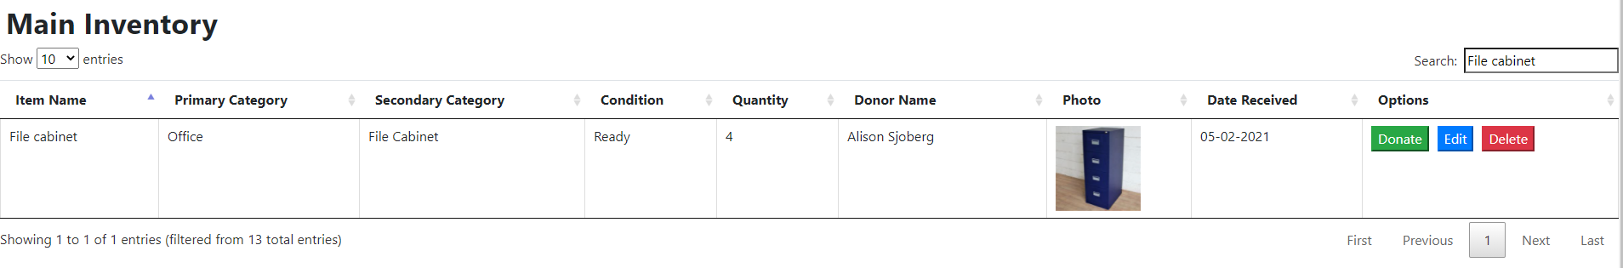

Each page contains an inventory table. This table contains the features to search and sort through items in many ways. The search box will search through every element, meaning the user can use this box to search for a donor name, item name, etc. with the same box. Clicking the column title will sort the columns in ascending or descending order. If there are more than the specified number of entries on the page, they will be given a new page, which can be accessed using the previous and next buttons on the bottom right of the table. To view more entries on a single page, a drop down menu is located at the top left to select the desired number of items per page.

Current Inventory : Displays all inventory currently in stock.

Inventory Counts : Displays total counts of each category currently in stock

Inventory Photos : A separate view with larger photos

Donation History : Viewable records of all past donations

## **Inventory Options**

Records on the current inventory and donation history pages have options associated with them. Clicking the button on an item row will perform the action on that item.



The Donate button is used to remove an item from active inventory and record it in the donation history. This button is only available on items in active inventory. This is generally done when an item is given out from the warehouse to a client. Clicking this button will open a menu with the information of the selected item pre-filled. If the item’s donor has registered contact information, it will appear here. If the donor’s email address is on record, clicking the Send Email button next to it will open a pre-filled email with their information in the Outlook or Mail desktop application. For more information on this email, see section 6.2.

In order to complete the donation, the user should fill in the donation date with the day the item was given out, and set the quantity in inventory to the new quantity. For example - if this donation has 4 chairs, and the volunteer gives out 1, the inventory record should be updated to show 3 remaining chairs.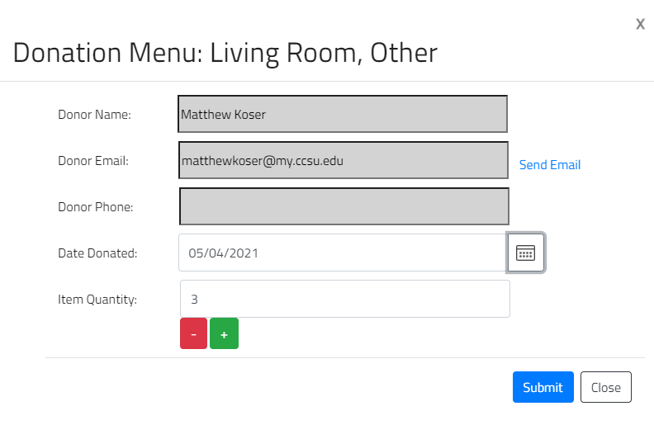

The Edit button is used to edit an item in active inventory or donation history. When selecting an item to edit, it will pre-populate all of the fields with the current information, meaning the user will only have to make changes to the fields they want to change.

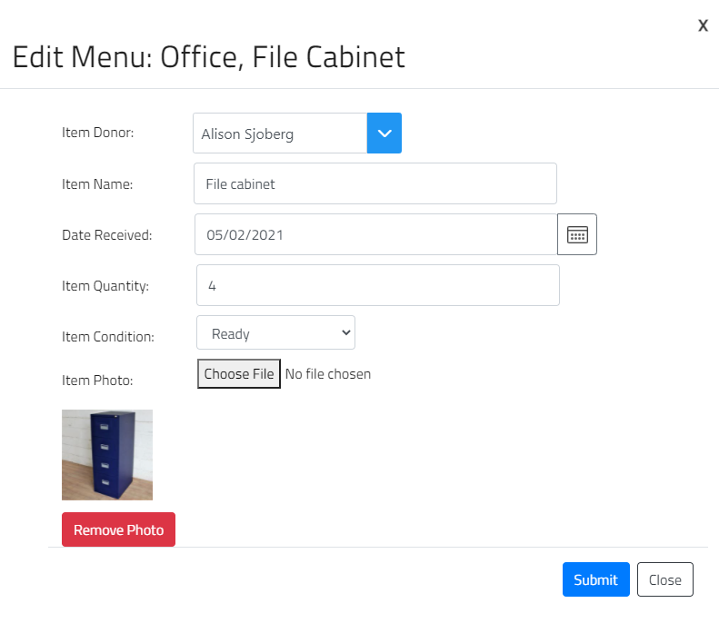

The Delete button is used to completely remove an item from active inventory or history. When the user clicks this button, the browser will ask for confirmation that they really would like to delete this item. If the user says yes, the item will be removed. This cannot be undone.

# **Adding Inventory**

The Add Inventory page presents the user with a form to fill out to register a new item to active inventory. This form supports adding multiple items, by pressing the green “Add Item” button to add a new row. Similarly, pressing the red “Remove Item” will remove a row and all of the data in it.

A donor must be selected from the Donor Information dropdown at the top of the page. This dropdown, when opened, will show a list of all registered donors. By typing a name into the area, it will provide a more specific list to select from.

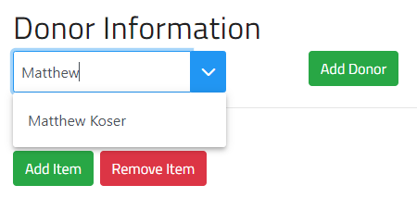

The selected donor must be registered in the system in order to appear in this box. The form will not be able to be submitted unless a donor is chosen. In the event that there is no donor for a certain item, for example an item is quickly given to a volunteer, there is a registered donor under the name of “*No Donor*” which can be used. If the donor has not been registered, they may be added to the system using the green Add Donor button. For more information on adding donors, see section 4.

The rest of the form is about entering information pertaining to the received items. Each item must be categorized using a primary and secondary category, as well as given a name. There is the optional ability to upload a photo of the time, by using the “Choose File” button. Each item can receive up to one photo, but no photo is required.

When all of the appropriate item information has been filled in, select the date the donation was received, and submit the form to register the items. If there are any errors, the system will show a message detailing the problem.

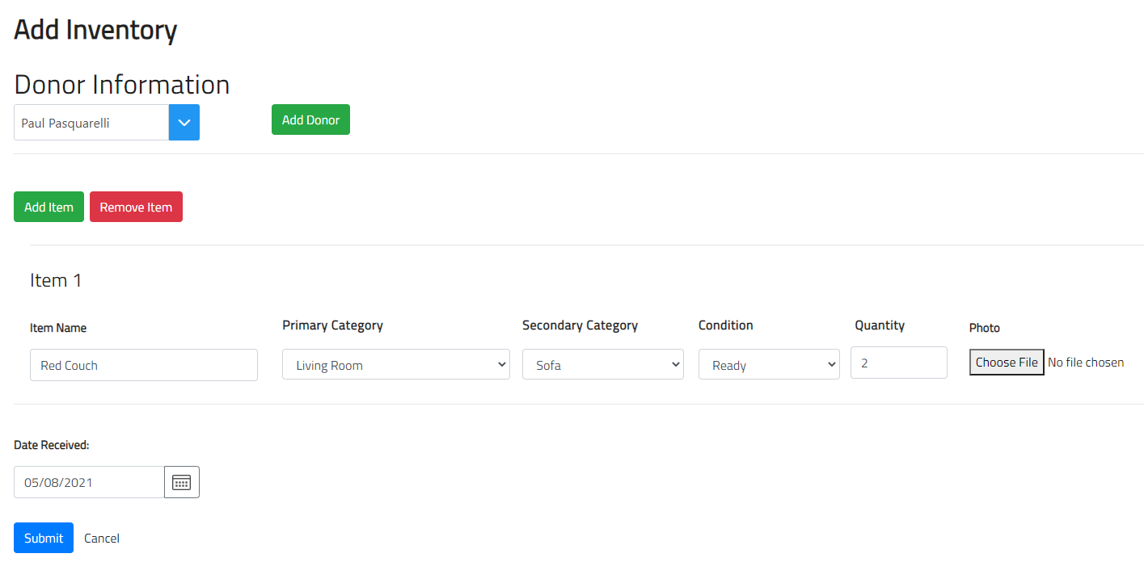

# **Inventory Charts**

Inventory Charts offer a quick and easy way to view breakdowns of active inventory, as well as information about donation history, wait time, and more. There are six total charts on this page.

## **Inventory Breakdown**

This chart shows an overall visualization of the amount of items in each category. When a category in the chart’s legend is clicked, that category will be removed from the chart. Clicking an inactive category in the legend will return it to the chart.

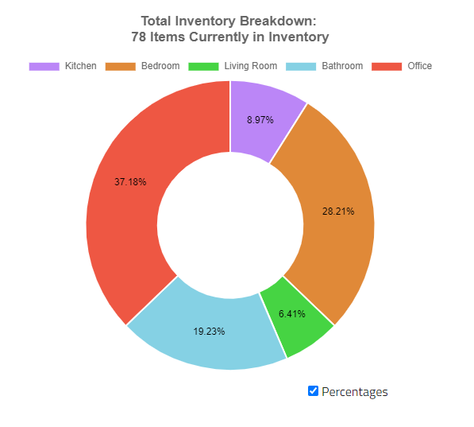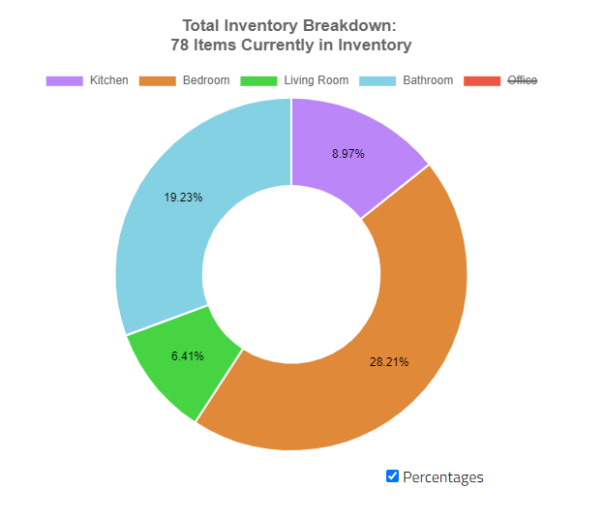

## **Donation History**

This chart shows a line graph of the total number of items donated per month, as well as the total number of donations per month. As with the previous chart, clicking either entry in the legend will remove it from the chart.

This chart allows the user to specify which months should appear on the chart, to view the overall intake of the organization. Each month including and in-between the specified months will appear.

If the month and year are the same in both selections, the chart will show each individual day of the specified month instead.

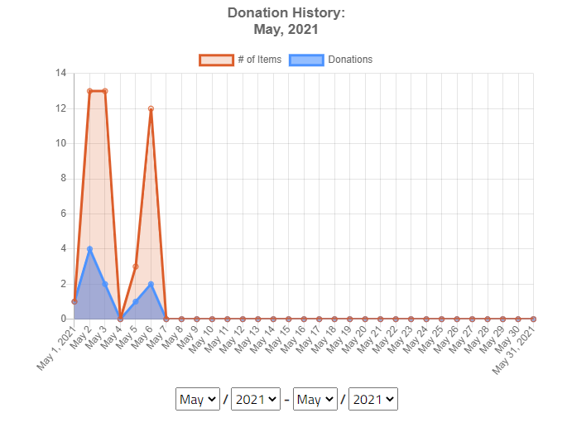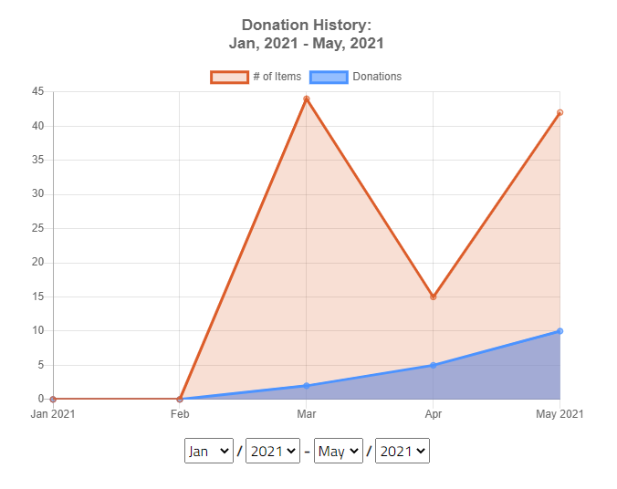

## **Average Hold Times**

This is a bar chart detailing the average hold times for each category of items. Hold time is how long items, on average, sit in the warehouse before being donated. Changing the month and year in the boxes below the chart will change the calculations.

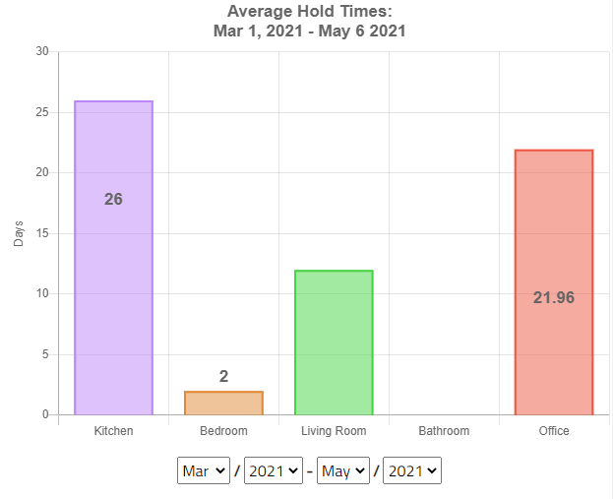

## **Bed Charts**

The final three charts are all specific to beds currently in inventory. This chart shows the counts of all three pieces to a full bed (Mattress, Box Spring, Frame), and a line showing the current number of complete sets. A bed is considered to be complete when all three pieces are together. This is represented by the red line on each chart. There is a chart for each bed size; twin, queen, and full.

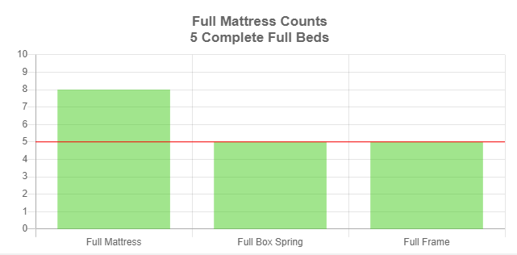

# **Donor Management**

All donors registered into the system are shown on the table on this page. Each donor may be edited using the blue edit button in their row. A new donor may be registered using the green Add Donor button at the top of the screen.

When creating a donor, their name is required. The email, phone, and town fields are all optional, but it is recommended that at least one way of contacting them is added, as it helps the organization reach out to thank them after.

Editing a donor is done in a similar box to creating a donor, but the information is already filled. The user can update any fields necessary, and submit to save changes.

When deleting a donor, the system will confirm that the user wants to delete them, and then remove their information from the system.

**CAUTION**: Deleting a donor will remove ALL of their information. This means that any items donated by them will have their donor changed to “*No Donor*” (This will not cause any items to be deleted)

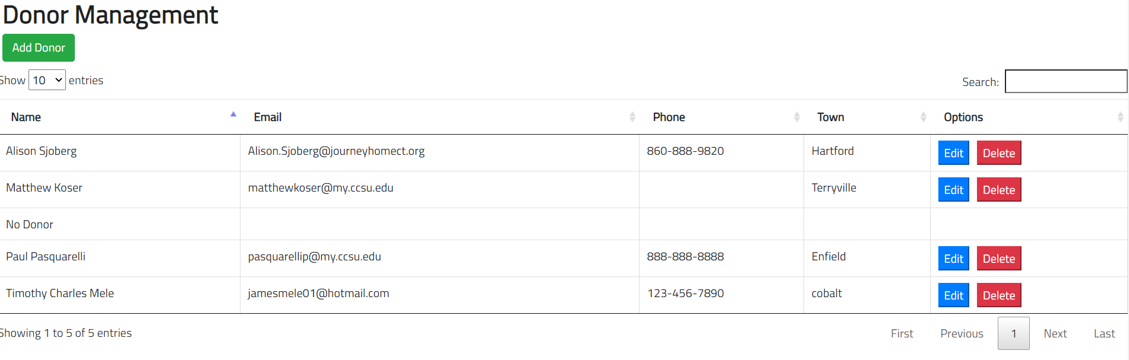

# **User Management (Admin Only)**

Anyone who is able to access this system is shown on the table on this page. Each user may be edited using the blue edit button in their row, and new users may be added to the system using the green Add User button.

New users are registered by an admin. The form asks for a username and password for the user, as well as if the user is an admin (True) or not (False). Once the form is submitted, the user will be created and can log in using this information. If a user needs their password reset, an admin can do so by selecting the blue edit button for the user, and pressing the red Reset Password button. If the user is deleted by an admin, they will no longer be able to log into the site using their email.

Admins are able to access all of the functions of the normal user, with the addition of managing users and changing the email template. **Admins can edit other admins’ information.** Most volunteers should be added as normal users.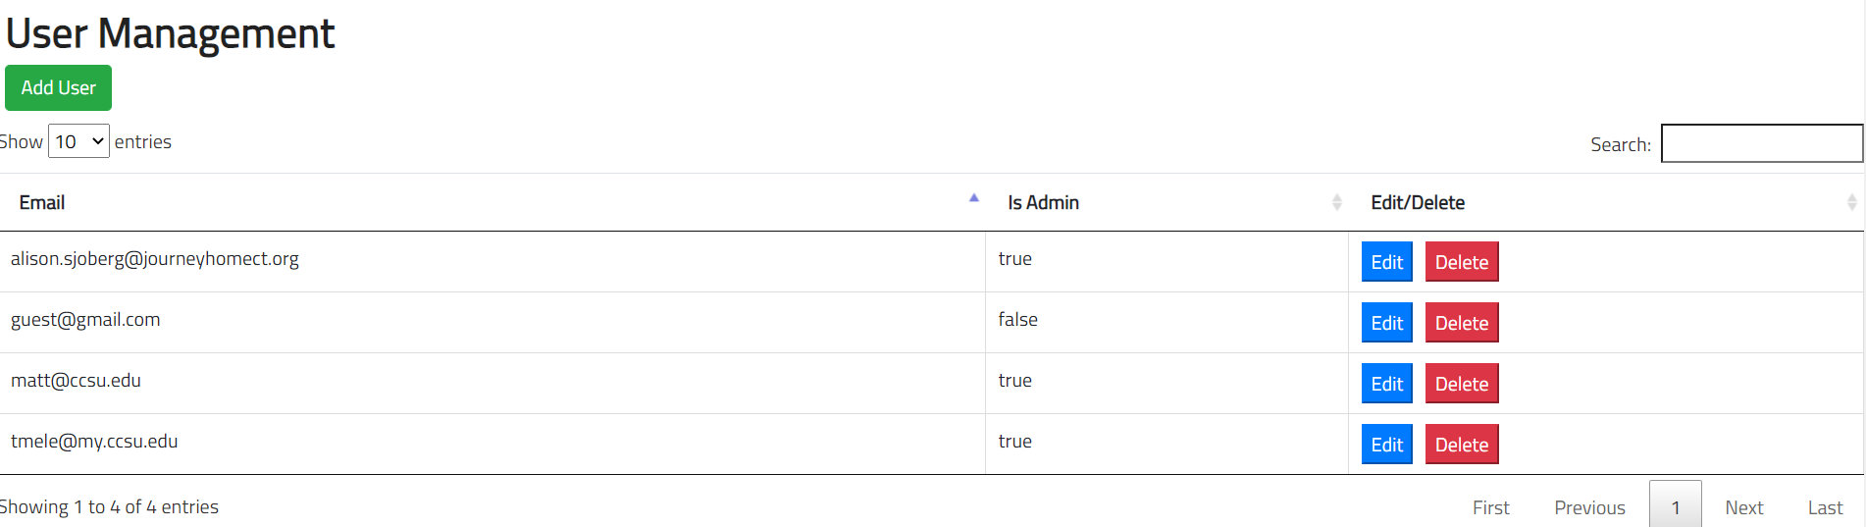

# **Options**

Options are accessible through the navigation bar, and contain three functions.

## **Export Data**

In the event that the user needs to create their own charts with information from inventory, the application offers the ability to export all data in a CSV file for the user. To help make it easier to generate charts and tables in Excel, the user can select exactly what information they want, and that will be the only information in the spreadsheet. When the user clicks the “Export” button, a CSV will be downloaded to the user’s computer. If the user exports both archived and current inventory, an extra column named “Archived” will appear, with either TRUE or FALSE to inform whether this is a past donation, or an active inventory item.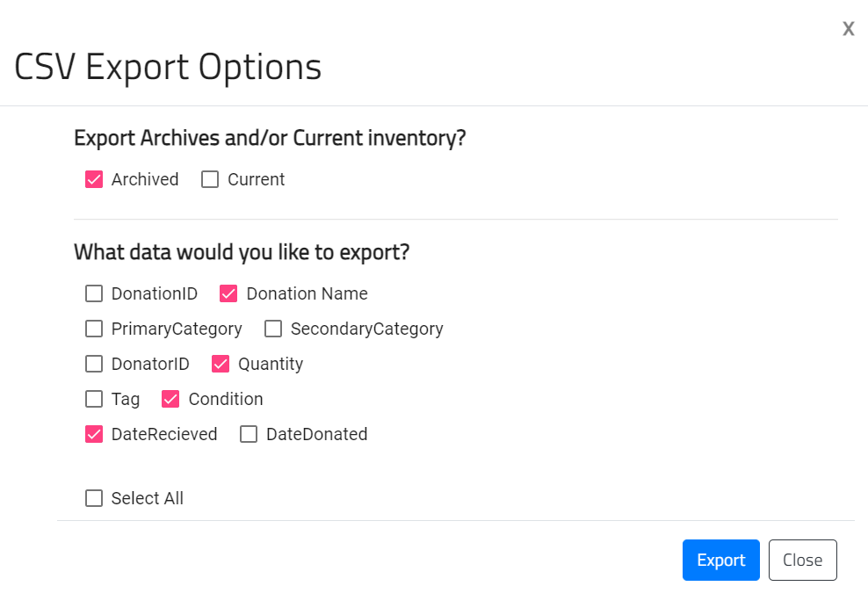

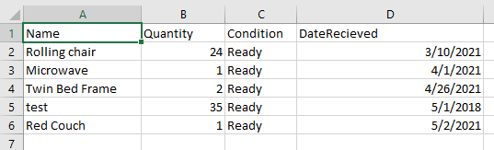

## **Edit Email Template (Admin Only)**

The email template is the automatically generated email created for the donor when the “Send Email” button is clicked in the inventory donation menu (See Section 1.2).

Admins are able to edit both the email header and body. As this is a template, certain placeholders are used which will be filled in properly in the actual email, similar to a mail merge. To use a placeholder, simply type in the code that represents what information is wanted in the email.   
  
For example, if the template is “Thank you #DN for your donation of the #IN!”, donating an item which has Matthew as the donor and an item name of “couch”, the email that is sent to the donor will be “Thank you Matthew for your donation of the couch!”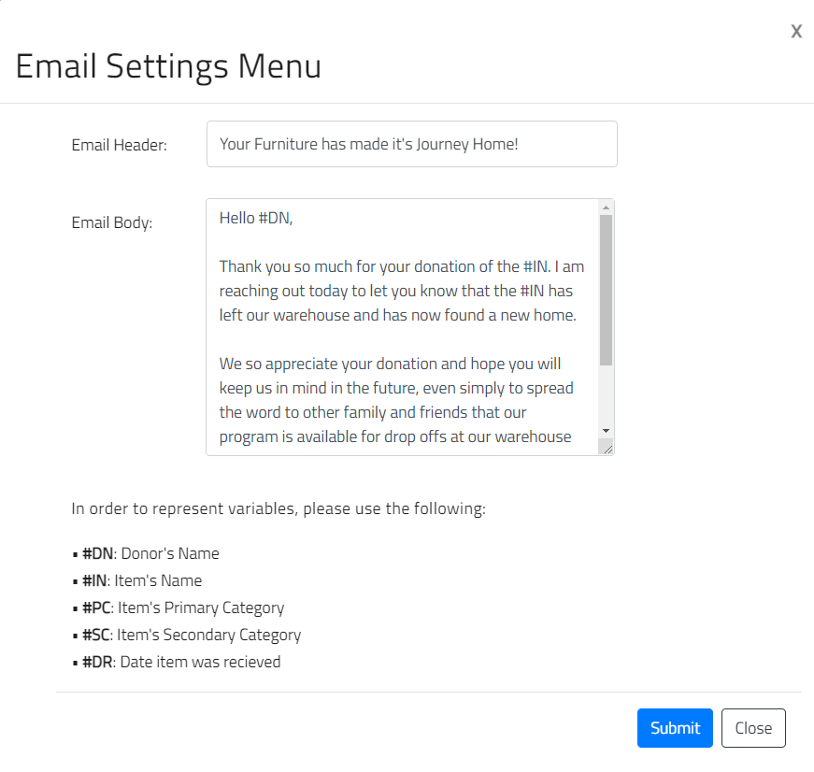

## **Logout**

Selecting this option will immediately log the user out, and bring them back to the login screen. It is especially important to log out of the session when using a shared computer.